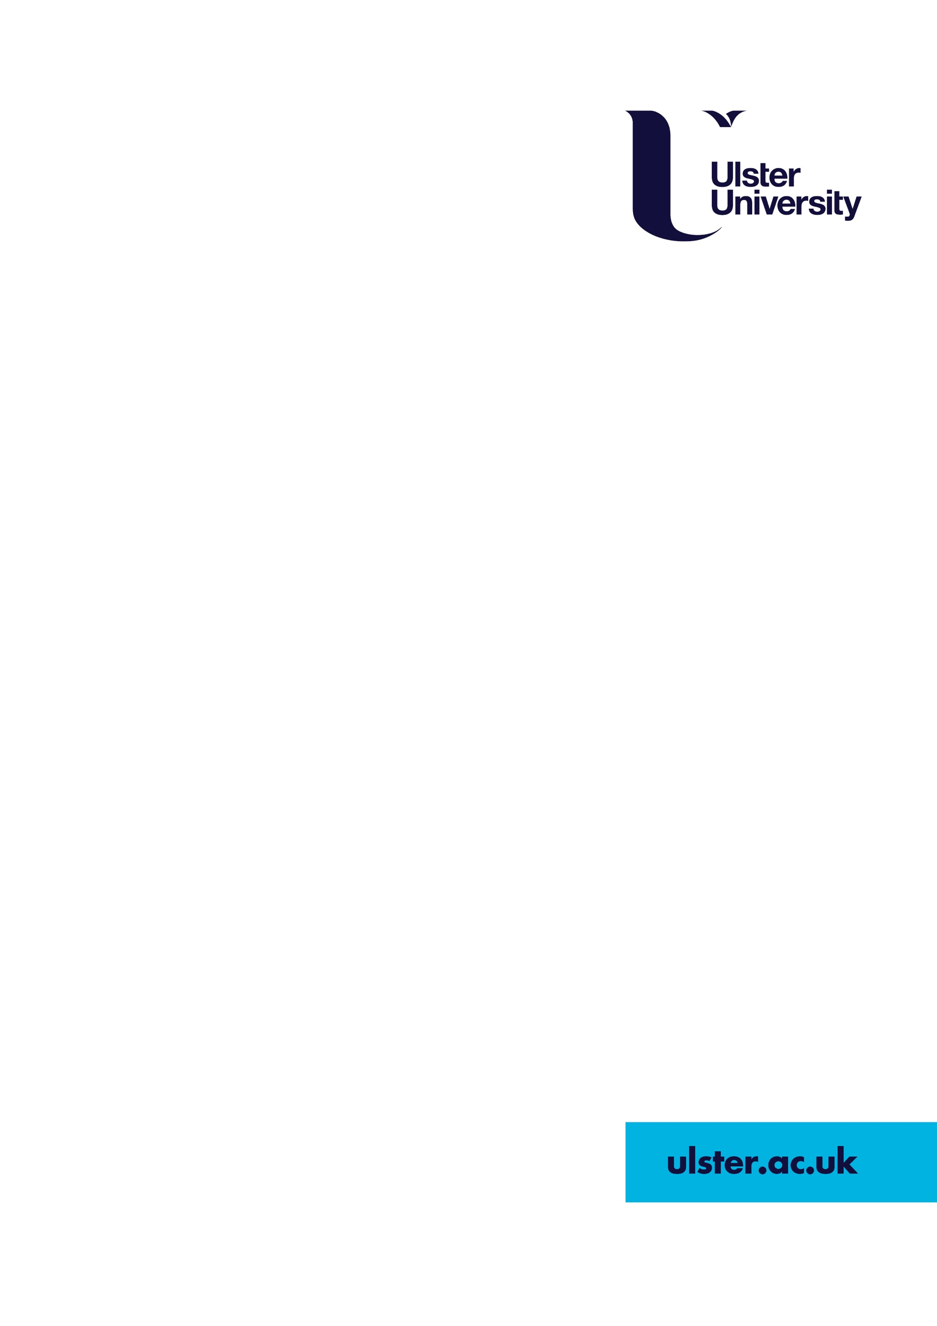

An Exploration of the Issues Impacting upon Peace Barrier Removal: A Paper for the International Fund for Ireland
Dr John Bell and Dr Philip McCready

Ulster University
Research Report
November 2021
Executive Summary

This report presents the findings of research commissioned by the International Fund for Ireland (IFI) on the issues impacting upon peace barrier removal. The purpose of the research was to independently document the experience and views of community participants from the IFI Peace Barrier Programme (PBP), alongside those of external stakeholders, on the process of barrier removal within the context of the T:BUC commitment to reduce and remove all interface barriers by 2023.

IFI’s Peace Barrier Programme is currently working across six interface locations in Belfast and Derry Londonderry to develop and deliver a range of confidence and relationship building interventions within and between interface communities to maximise the potential for residents to feel safe, secure and content for such peace barrier removal/reduction, reimaging or de-classification to occur.

Researchers from Ulster University conducted focus groups and semi-structured interviews with 40 individuals throughout September and October 2021 (21 staff from the Peace Barrier groups and 19 stakeholder representatives). The discussions aimed to assess thoughts on barrier removal work to date – with regards to the main successes, the key challenges, and how interviewees would like to see barrier removal work progress moving forwards. Interviewees were guaranteed anonymity and any direct quotations used in the report have been coded as follows (Peace Barrier Group = PBG and Stakeholder = S/H).

It should be noted that there is no agreement on the exact numbers of interface structures which exist, primarily due to differing methodologies for counting structures between statutory and community-based organisations. However, the available research evidence indicates that those living in the shadows of the peace-walls suffer from multiple and overlapping issues in relation to socio-economic disadvantage, educational under-attainment, limited mobility and access to services, and poorer levels of mental and physical health and well-being. In this context it should be borne in mind that almost 70% of all conflict-related killings in Belfast between 1966 and 2001 took place within 500 metres of a peace-wall (Shirlow, 2003) while 86% of those living within 400 metres of a peace-wall are living in areas within the most deprived quintile of the Northern Ireland Multiple Deprivation Measure (Gormley-Heenan et al., 2017). It is perhaps of no surprise that research has found that living in a neighbourhood segregated by a peace-wall increased the likelihood of using anti-depressants by 19%, and of anxiolytic medication by 39% (Maguire et al., 2016). The functions of peace-walls are therefore complex and include issues relating to security, community relations, health and well-being and culture and identity (Byrne et al., 2012).

Yet despite these issues, recent survey data suggests that there has been, via initiatives such as the PBP, progress in relation to resident attitudes with regards to the function and removal of the walls. In 2019, 76% of interface residents surveyed were strongly in favour of barriers being removed within the lifetime of their children or grandchildren (compared to 68% in 2017). In addition, 19% of interface residents surveyed in 2019 said they wanted the walls ‘down now’ compared to 13% in 2017 (IFI, 2019).

Discussions with interviewees as part of this research project have identified several positive impacts of the PBP to date. These include:

- Improved and strengthened relationships between staff, organisations and residents across the interfaces;
- Improved relationships have allowed the space for deeper conversations to explore attitudes to the peace-wall and their potential removal;
- Participating PBP groups have become more strategic in their barrier reduction work, augmented inter-community engagement work, and are delivering challenging programmes dealing with sensitive legacy and perception issues;
- This work has reportedly facilitated greater levels of resident movement between and across interface areas; and
- There has been a reduction in the total number of peace barriers (via removal, reduction, reimaging and de/reclassification).

However, analysis of the interview data revealed key challenges facing those working to achieve barrier reduction. These include:

- Lack of an overall, coordinated and sufficiently resourced inter-departmental strategy and action plan to progress barrier removal;
- Lack of proper accountability structures to measure progress;
- The short-term nature of the funding environment which makes it difficult to strategize for longer-term plans;
- Lack of political commitment to driving the T:BUC 2023 strategy, possibly tempered by local political concerns around vote loss or territorial encroachment following barrier removal;
- Ongoing issues relating to security, identity, housing, community safety and policing;
- Long delays in the barrier removal process which leads to a loss of community confidence - particularly around aftercare provision;
- Issues around the consultation process itself – particularly around community consent – leaving a role for community gatekeepers;
- A general lack of trust between community and statutory representatives;
- A perceived lack of communication and coordination within and between statutory organisations themselves and between statutory and community organisations.

There was general consensus that the T:BUC setting of a date for the removal of all barriers was unhelpful:

‘The 2023 date wasn’t helpful. You can’t – the paradox is when you set a firm date – yet say that community consent is essential – you can’t then dictate the pace. At the same time, having a shared and well-established commitment is helpful – I’m just not sure putting a timeframe on it is.’ (S/H)

Yet even more significantly the research revealed a deep frustration amongst community participants and external stakeholders with the delays in the process of barrier removal to date - which it was felt was stalled by bureaucracy:

‘It’s a snail’s pace of progress. It could have a detrimental impact on IFI and the groups. Going out rapping doors, surveying the community, considering change. That takes ages. But there is a risk of losing community support and goodwill.’ (S/H)

‘You look like a clown. (Names removed) here consulted seven, eight times with residents.... They are not making the same progress that communities are making.’ (PBG)

It was felt that there was a need for a much more rapid response to deliver change when local communities agreed to it:

‘When community agreement is secured and there is an understanding that something can happen there needs to be no bureaucratic impediment… There should be no slowing things down… You’ve got to hit it with the hammer while it’s hot.’ (S/H)

Delays with regards to the provision of aftercare for residents were highlighted consistently. Many interviewees complained that despite aftercare being ‘promised’ back in 2013, it was not approved until 2019 – and even then, it was still not fully operative and there remained significant gaps in content:

‘There are no proper policies around aftercare. It only just happened there… And yet aftercare gives people confidence… You have to build the confidence of residents. It’s really hard to talk about a fictitious aftercare package – budgets have to be set in place. You can’t ask residents to agree to major change without that.’ (PBG)

Defining what constitutes community ‘consent’ was also highlighted as problematic. While some interviewees noted that as public servants they must consult as widely as possible, others felt there was a lack of consistency in approach to consent and that the views of those living in the shadows of the walls should be prioritised (although there was consensus that there was no simple matrix or percentage of consent which should be prescribed):
‘It has to be wider – but critical weight given to someone who lives right at a barrier. You need a blend of both for consent. We need to be pragmatic about consent - I don’t like the idea of a strict percentage being put to it.’ (PBG)

The challenges identified in working towards barrier removal had impacted upon trust and relationships between community and statutory partners – although there was a willingness on all sides to find a way to improve communication, relationships and partnership working. However, while interviewees were in favour of more positive relationships, some suggested that the systemic difficulties encountered thus far required alternative delivery mechanisms to better progress barrier removal:

‘An independent body is needed. The land is in public ownership but the issues and responsibility aren’t being addressed… Partnership working hasn’t achieved a huge amount... It doesn’t lead to quick decision making. The whole thing freezes up in that type of decision making… We need an independent body not beholden to politics.’ (S/H)

Ongoing work to reduce and remove interface and peace barriers across Northern Ireland is a hugely challenging task, both for community and statutory organisations. For the former however it is made even more difficult by the fact that many community representatives are also from the communities in which they work. In this regard they feel the stresses and strains (and blames) of delays in a process which various pieces of research over the years (Blomqvist, 2016; Byrne and Morrow, 2021; Social Change Initiative, 2021) suggest there are systemic weaknesses in.

However, progress to date within the PBP and barrier reduction work more generally should be recognised – the building of relationships and trust which were able to withstand what could have potentially been a violent summer in 2021; an increased strategy to the work; deeper conversations with local residents with a view to ascertaining their views on changes to the barrier; and completed and ongoing works at a number of sites which have delivered some form of positive change with regards to the aesthetics, accessibility and land use of interface locations.

Yet throughout this research, there was a deep frustration amongst all PBP staff and most external stakeholders that more could and should be done; that progress was too slow and delays were impacting upon community confidence and undermining the work of the groups themselves. It is worth recalling the previous findings of Jessica Blomqvist in 2016 with regards to barrier reduction work in interface areas. She found that:

- There was a lack of flexibility in addressing interface structures (with some residents feeling the process was ‘too rushed’);
- There were resource limitations which prevented ‘quick wins’ and damaged community confidence in the process;
- There was a lack of coordination and partnership working amongst statutory organisations;
- There was a lack of political buy-in and support for barrier removal from politicians on the ground;
- Community consultation and how it was conducted was problematic with issues relating to ‘research fatigue,’ no agreed definition of consent and depending on the forum for debate, there was a fear of some residents to ‘speak their mind’;
- Issues around legalities and ownership which at times caused delays to barrier removal work; and
- There needed to be more focus on socio-economic incentives and regeneration to promote barrier removal (Blomqvist, 2016).

Five years later, this research has largely found these issues are all still hugely problematic for barrier reduction and removal – which also likely explains the frustration amongst many interviewees.

On issues such as counting the number of interface structures, conducting community consultation and securing consent and aftercare, in many instances there would appear to be parallel processes between statutory and community organisations running alongside one another – duplicating work, undermining trust and relationships and the process itself. While addressing some of the structural weaknesses of barrier reduction work is crucial, at an even more basic level, it is important to begin to repair and rebuild relationships between community and statutory partners which have been strained by these difficulties – particularly given the shared goals of reducing the numbers of interface structures. This won’t necessarily be easy, but if achieved, would be fundamentally worthwhile.

The research offers the following recommendations to inform the delivery of barrier reduction and removal work moving forward.

Strategic:
- R.1 There should be a review of the T:BUC 2023 Strategy to include a reaffirmed cross-party political commitment to the removal of interface walls and barriers which sets out the ‘scaffolding’ by which this process will be achieved (albeit without distraction target dates).
- R.2 The Review should include an exploration of alternative delivery mechanisms for barrier removal given the cross-cutting and cross-departmental nature of the work. This exploration should involve all statutory departments and stakeholder agencies, including IFI, and have community representation.
- R.3 To encourage positive change, there should be a greater inter-departmental and stakeholder focus on the potential for socio-economic regeneration and the designing out of barriers via improving the local environment, with consideration given to quality-of-life issues and health/well-being, use of existing amenities, education and employment opportunities.
- R.4 A cross-departmental strategy with Operational Delivery Plan/route-map should then be developed to set out the practical path by which work on barrier reduction and removal is to progress.
- R.5 The role of the Interfaces Programme Board (IPB) should be clarified. If the primary function is a focus on partnership working, a separate accountability mechanism would be required to oversee progress on the delivery of the Peace Barrier Removal Strategy and Action Plan. This accountability mechanism should include IPB, Stakeholder and community input.
- R.6 The IPB and Accountability Mechanism should reaffirm the well-established principle in terms of community consultation that decisions to act on barrier reduction, where agreement has been secured, should be taken as quickly as is practically possible.

Relationships:
- R.7 Better use and respect for existing local Reference Groups (which include community and statutory stakeholders) would ensure that a proper ‘culture of partnership’ governs both decision-making and the process of community consultation. This would guide plans for barrier removal/change, who and where in the target area is to be consulted, how this consultation is to take place, who will carry out the consultation, how the data will be analysed, and how the data will be stored and shared. If participant organisations sign-up to a transparent process in relation to this, it will prevent mutual suspicion.
- R.8 As part of this process, efforts should be made on all sides to rebuild trust and relationships to ensure the priority is barrier transformation in order to improve the lives of communities living in the shadow of peace barriers on or around interfaces.
- R.9 It became clear that while several PBP projects reported positive relationships with the PSNI, there remain issues in terms of relationships and trust between Neighbourhood Policing Teams, PBP groups and local communities. Improving relationships would require a commitment to re-engage with PBP Reference Groups to ensure better understanding of the lived experience at interfaces.
Process:
- R.10 The issue of Consent: This research would suggest that there is no simple formula or percentage to apply to community consent given the differences at each interface site – however, there was general agreement that priority should be given to those who live closest to a barrier (albeit there needs to be wider community consultation as well). The reference to ‘weighting’ within the Department of Justice (DoJ) Framework Document (DoJ, 2019: 11) should be further developed, with input from stakeholders, to provide some clarity and transparency for residents in the absence of any agreed community consent figure.
- R.11 The Aftercare Scheme: Clarity should be provided via discussion between DoJ, statutory and community partners, including the PSNI, on aftercare provision; what it entails, how security assessments are completed, the implications for the community impacted, and how aftercare proposals are presented to local residents. There is a perception from community representatives that aftercare is not given enough priority. There are also concerns that the security fears of local residents are not taken on board; yet some statutory representatives feel that aftercare has become too all-encompassing and they prefer to focus on ‘assurance’ as opposed to ‘insurance.’

References

Blomqvist, J. (2016) Peace Walls and Barrier Removal: Building Sustainable Communities. Belfast: BCRC.

Byrne, J., Gormley-Heenan, C., and Robinson, G. (2012) Attitudes to Peace Walls: Research
Report to Office of First Minister and Deputy First Minister. University of Ulster.

Byrne, J., and Morrow, D. (2021) Additional observations on funding in interface areas. Belfast: UU.

Department of Justice (2019) Interfaces Programme: A Framework Document. Belfast: DoJ.

Gormley-Heenan, C., Morrow, D., Byrne, J., Rosato, M., and Cook, S. (2017) ‘Analysing Baseline Data around Peace Walls (4) Who are the people?’ Institute for Research in Social Sciences Policy Brief. file:///C:/Users/John/Desktop/Policy%20Brief%204%20Peacewalls.pdf (accessed October 12th 2021).

International Fund for Ireland (IFI) (2019) Peace Walls Programme: Attitudinal Survey. Summary of Results. Belfast: IFI.

Maguire, A., French, D., and O’Reilly, D. (2016) ‘Residential segregation, dividing walls and mental health: a population-based record linkage study,’ in J Epidemiol Community Health, Vol.0, pp.1–10. Open Access Journal.

Shirlow, P. (2003) ‘Who Fears to Speak: Fear, Mobility and Ethno-Sectarianism in the Two Ardoynes,’ in The Global Review of Ethnopolitics, Vol.3(1), pp.76-91. Special Issue: Northern Ireland.

Social Change Initiative (SCI) (2021) Reflections on Investing in Building Infrastructure and Community Engagement in Interface Areas. Belfast: SCI.



ulster.ac.uk

